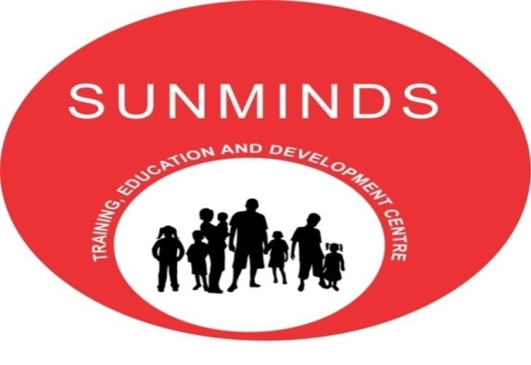

A JOINT VENTURE OF SUNDERJI’S INSTITUTIONS AND MINDBRAIN SOLUTIONS
SUNMINDS PRESENTS 1 DAY WORKSHOP ON PLAY THERAPY
THE MODULES THAT WILL BE COVERED IN THE WORKSHOP ARE:-
- What Is Play Therapy? | - How Play Therapy Helps In Emotional And Behavioral Problems In Children?
- Play Therapy Material | - Types Of Play Therapy
- Play Therapy In Adopted Children & Abused Children | - Case Studies And Mock Sessions

THE RESOURCE PERSONNEL FOR THE WORKSHOP IS:-
Mrs. Anupama Ganu:
Mrs. Anupama Ganu has done her Masters in Child Development. She has also done Family Counselling course from Minnesota University, US. Mrs. Anupama Ganu has been working as a play therapist since 2005. She has worked with a number of organisations like Mangeshkar Hospital, Bharatiya Samaj Sewa Kendra,etc. She is currently working as a Play therapist with Dr. Sanyogita Nadkarni at Positive Steps.
DETAILS OF THE WORKSHOP:
- Price Of The Course – Rs. 2,000/-
- Time: 10 am to 5pm
- Date : Saturday, 5th July 2014
- Venue : Sunderji’s Institutions
We Hope To Have You As A Participant For The Workshop.
Salient Features:
- Self Explanatory PowerPoint Presentations.
- Handouts will be given to all participants.
- Mock sessions of play therapy will be given to whoever requires.
- Certificate will be given after the completion of the workshop.

