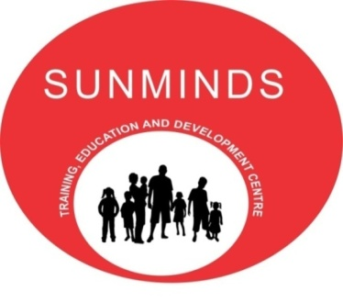

A JOINT VENTURE OF SUNDERJI’S INSTITUTIONS AND MINDBRAIN SOLUTIONS
SUNMINDS PRESENTS 1 DAY WORKSHOP ON TEACHING AND COPING STRATEGIES
THE MODULES THAT WILL BE COVERED IN THE WORKSHOP ARE:-
- Needs And Benefits Of Teaching Strategies | - Types Of Strategies- TRIMS, K-W-L Paraphrasing, SQ3R And More
- Coping Strategies Like Techniques To Improve Reading, Taped Reading | - Coping Strategies For Dyscalculia/ Dyspraxia Etc.

THE RESOURCE PERSONNEL FOR THE WORKSHOP ARE:-
Mrs. Masarrat Tavawala- She has a bachelor’s degree in Psychology and has also done her Masters in Child Development. Along with these, she has taken remedial training at Alpha to Omega and done certificate courses in Counseling and Guidance. She has been the Principal and Director of Sunderji’s Institutions for almost 24 years now and has conceptualized, developed and executed the remedial centre for children with Special Needs.
DETAILS OF THE WORKSHOP:
- Price Of The Course – Rs. 2,000/-
- Time: 10 am to 5pm
- Date : Saturday, 28th June 2014
- Venue : Sunderji’s Institutions
Salient Features:
- Self Explanatory PowerPoint Presentations.
- Handouts will be given to all participants.
- Certificate will be given after the completion of the workshop.

We Hope To Have You As A Participant For The Workshop.

