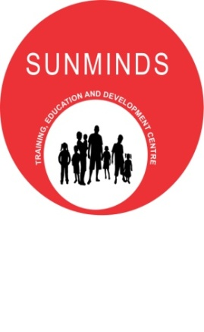

Warm Greetings from SUNMINDS – Training, Education & Development Centre.
SUNMINDS is a joint venture by Sunderjis’ Institutions & MindBrain Solutions.
Sunderji's Institutions believe in Educating, Enlightening and Empowering young minds to develop as global citizens who are socially responsible, creative, and clear in thought, explorative with good self management and interactive skills.
They offer varied services in the field of education and training-a Kindergarten School, a training center for aspiring teachers, remedial centre and an open school for children with special needs.
Sunderji's has 40 trained staff members including teachers and special educators. It has provided services to over 5000 children since 1984.
MindBrain Solutions is a professional centre dedicated to children and adults with Special Needs, led by a psychiatrist, Dr. Sanyogita Nadkarni. The centre provides service in different specialties like ADHD, Autism, Learning Difficulties, Behavior Problems, Social Skills Training, Teenage Counseling, Career Guidance as well as Specialized Services like Risk Assessment and Problem Solving for Adults with Special Needs.
Dr. Sanyogita Nadkarni, who is the Clinical Lead and Coordinator at MindBrain Solutions is trained in UK and is a Member of The Royal College of Psychiatrists (RCPsych), UK. Through her professional affiliations with the RCPsych(International Links) and the British Indian Psychiatrists Association(BIPA), she aims to bring the latest knowledge-base to India.
MindBrain Solutions has 6 trained psychologists and has served 350 children since its inception in 2008.
SUNMINDS Accomplishments:
- SUNMINDS has been conducting IQ and developmental assessments and psychological evaluations for children with Learning Difficulties, ADHD, Autism, Behavioral Issues etc.

- We conduct workshops for parents, teachers and professionals to help maximize the awareness of the disorders.

- We also have started with a Parents Support Club, where we provide the parents of special needs children with knowledgeable workshops that they would require to cope with the challenges of Special Needs Children.

- SUNMINDS has been conducting out station awareness workshops for teachers and professionals on topics of special needs. The latest workshop we conducted was in Hyderabad for the Care4Autism Centre. It was a 5 day remedial teaching workshop and SUNMINDS and the Team received very promising feedback.

- With much positive feedback after the workshop, we are now working on developing a Learning Disability Centre for the same organization we held the workshop for.

- We are also developing a Learning Disability School in Malad, Bombay.

- With the growing needs for awareness, we have now been asked to conduct awareness workshops in United Arab Emirates, Dubai.

