Solutions
Managing Educational issues the professional way
otal Solutions

# A-4, M.R. Towers, Near Pallavi Model School, Manovikas Nagar, Bowenpally, Secunderabad – 500009.
Cell: 9885188697, 9440132360

PEDAGOGY
Solutions

OBJECTIVE OF THE PROGRAMME

Facilitate the teaching and learning process by equipping the teachers and other professionals with more strategies to deal with variety of challenges imposed by children with learning difficulties or learning environment.

What can be expected out of the training program?
On completion of this program remedial instructor will be able to use effective strategies for;
- Establishing and running a resource room in a regular school system for children with learning difficulties.
- Identifying and managing learning problems in the students, like
  - Learning disability
  - Attention deficits
  - Hyperactivity
  - Underachievers
  - Slow learners
  - Speech and language delay
  - Cognitive training for children with Epilepsy
  - Remedial and cognitive training for children with Sensory Processing Disorder (SPD).
c. Dealing with problem behavior occurring specifically in class-room
situation
- Dealing with issues related to parents and discipline

- Strategies to make effective classroom teaching by providing support for development of
- Effective Reading skills
- Effective Writing Skills
- Effective Mathematic skills

CONTENT OF THE PROGRAMME

Content the training program will focus on following topics
I specific learning disability
II slow learning condition
III childhood emotional problems
IV childhood behavior problems
V parenting and discipline
VI counseling

Special Features if the program
- Movement therapy
- Cognitive training
- Activity based brain stimulation
- Handwriting strategies

Duration: 1 month (1st May to 30th May, 2012)
Timings: 10:00 a.m. to 1:00 p.m.
6 days in a week (Sunday will be holidays)

OTHER DETAILS

Fees: 25,000/Rs (non refundable)
The fee is for full course including the study material. The fees can be paid either in cash or in Check, favoring Pooja Jha.
Admission to this programme is restricted to 20 participants only

Venue: Dyslexia Association of Andhra Pradesh (DAAP)
3-4-494/1/2, 1st Floor, Genesis Towers,
Above Indian Bank (Barkatpura Branch),
Barkatpura main road, Reddy College Road
Hyderabad – 500027, +91 40 27566655
www.daap.in

Methodology of Training
Classes are conducted through multimedia mode and group discussions are encouraged. Maximum input is on practical to give hands on experience to the trainees. Each day is split into theory class, practical sessions, testing sessions and intervention techniques. A parallel process of understanding the difficulty and management of the same helps the trainee to develop better understanding and induces confidence for using the same in real life situation.

Evaluation: Evaluation of the participants will be done in three ways; Written Exam at the end of the course, Viva and internal assessment. Total evaluation will be of 500 marks as explained below;

- Written Test of 100 marks (division of 100 marks as follow)
- Objective question test-60 marks
- Short Questions 20 Marks
- Essay questions 20 Marks

- Internal Assessment-200 marks
- Assignments -100 marks
- Practicals-100 marks

- Hypothetical Case – 100 Marks

- Viva – 50 marks

- Group Presentation-50 marks

Internal assessment will be based on
- Commitment towards work
- Creativity in developing activity sheets
Approach to the subjects of practical
- Punctuality
- Attendance
- Involvement

AWARD OF CERTIFICATE
Candidates who will score more the 50% in overall evaluation will be awarded with ‘competence certificate’. Below 50% candidates will be awarded with ‘facilitator’ certificate. ‘Excellence’ certificate will be given only to those candidates who will score more then 75%.

This course is not affiliated/recognized by any university. Total Solutions doesn’t guarantee any job based on this programme. Assistance would be provided on informal basis for job placements.

About the Trainer
Mrs. Pooja Jha Nair is a certified professional from Rehabilitation Council of India (RCI) and she is Master Trainer for PASS Based Reading Enhancement Program (PREP) and Cognitive Enhancement Training (COGENT). She has finished her Special M.Phil Program in Rehabilitation Psychology from NIMH, Secunderabad. She is a Ph.D Scholar of Osmania University. Mrs. Nair has completed tutor training program of Alpha to Omega, Chennai. She has work experience of 13 years in the field including one year work experience in United States. On hand experiences of the trainer help trainees to get an insight into their learning. It makes a holistic experience possible.
She has successfully conducted five training programs of “Pedagogy Solution”. She conducts frequent works shops for parents and teachers in different schools of Hyderabad.
Her main objective of conducting this programme is to equip more and more people with techniques and strategies to deal with learning difficulties of school going children as well as to enhance their inherent potential.
Mrs. Pooja Jha Nair is consultant with following schools and Clinics;
  - Abhyasa School, Tooparan
  - Chaitanya Vidyala (Lower Tankbund, Hyderabad)
  - Bhartiya Vidya Bhavan, Jubilee Hills
  - Aurbindo International School, Vidya Nagar
  - Indian School of Excellence, Tolly Chowky
  - Indus World School, Sainik Puri
  - Sri Siddhartha Rehabilitation Center, Srinagar Colony
  - Learning Solutions, Bowenpally
  - Learning Solutions, DAAP
  - Smile School, Himayat Nagar
  - Learning Solutions, Banjara Hills Road No. 12
  - Learning Solutions, Srinagar Colony
  - Learning Solutions, Masab Tank, Hyderabad

Material provided with the course
- Kit for cognitive intervention
- Testing material
- 1000 square cut flash cards, 250 rectangles cut flash cards with box to carry
- Stationary, including 250 blank sheets to make worksheets, a note book, sketch pen set, crayon set, two pencils, erasers, sharpener, set of pens, ruler, and folders to carry worksheets and for submission of assignments, a handbag to carry the kit.
- A CD with sorted worksheets and presentations for future use.
- Below picture shows material Kit
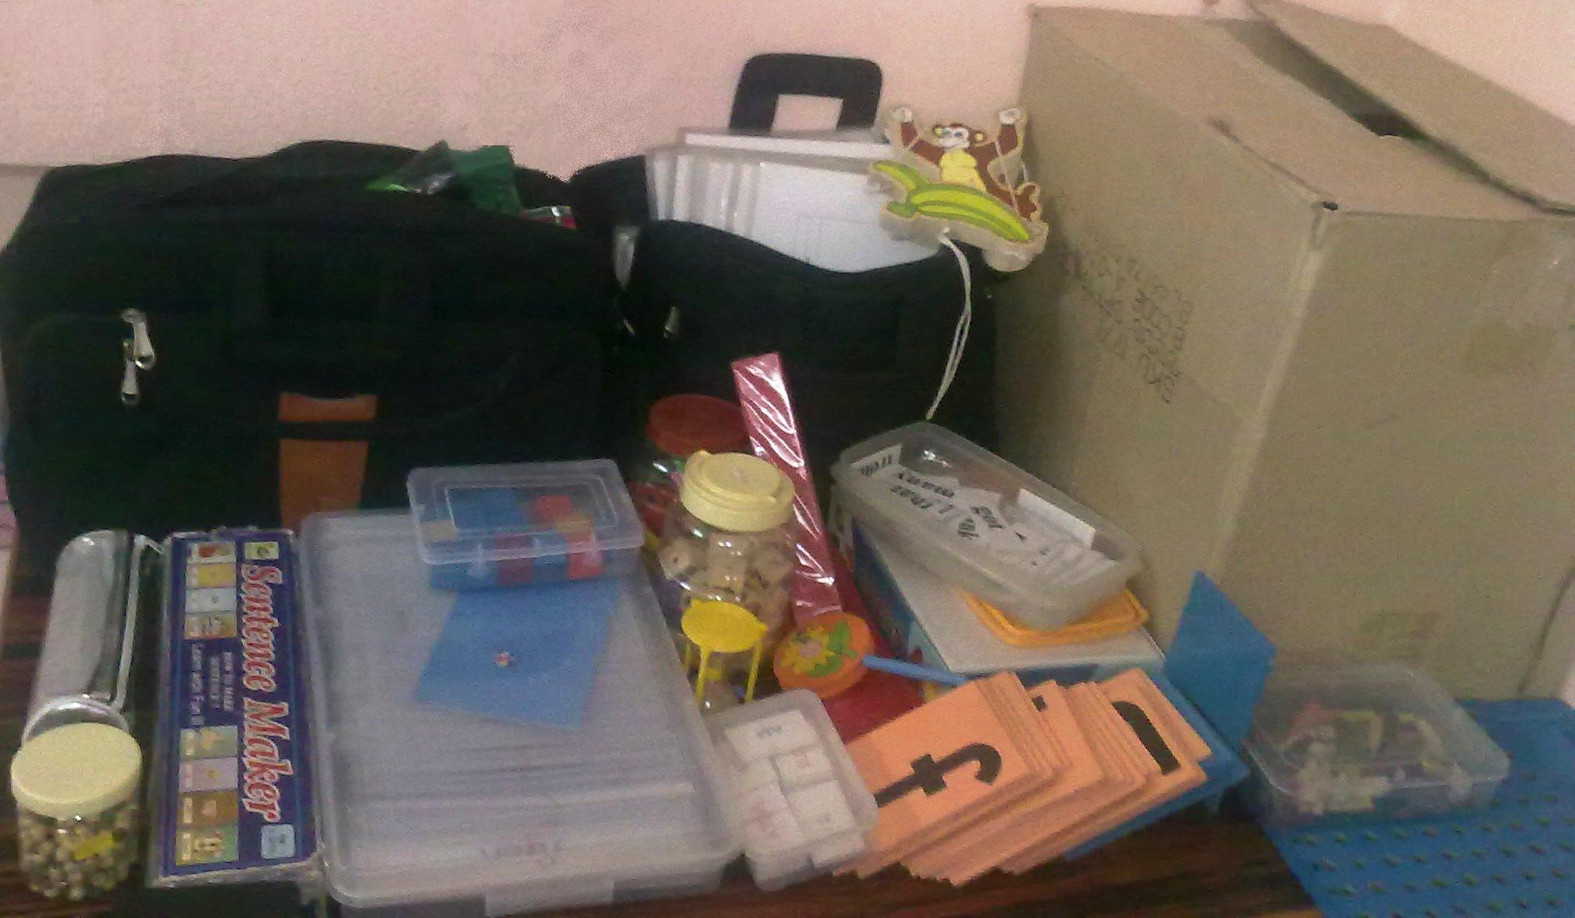

APPLICATION FORM

AFFIX YOUR RECENT PHOTO HERE

NAME : __________________________________________
(IN BLOCK LETTERS)
M F
AGE : ____________ GENDER
Qualification : _______________________________________________________
Address : ___________________________________________________________
________________________________________________________ ___
___________________________________________________________
Phone no : _______________________ Mobile __________________________
Present job status : _________________________________________________
Years of Experience : _______________________________________________
Experience in the field of Special Education if any : ___________________
_____________________________________________________________________
Expectation from the Programme : ___________________________________
_____________________________________________________________________
_____________________________________________________________________
Please attach a copy of your recent degree or diploma.

Declaration
I Mr. /Ms. /Mrs. ____________________________________ hereby declare that I understand all the terms and conditions of this programme and hereby accept to abide by the same as a candidate.

Date: Signature

